Chicago’s Violence vs Public Schools

Arslan Munir

5/3/2018

# Intro

Do school closings have an impact on Chicago’s violence? In recent years Chicago has seen a spike in homicide rates across the city, but mostly in the South and West sides. Also, in 2013 43 public schools were closed down across the city, but mostly in the South and West side. The purpose of this research is to see if there is a correlation between violence due to the closings. Newspaper articles and other sources will be used to obtain information and will be analyzing data through r programming to see the correlation between the two. Although many factors contribute to the violence in Chicago, it will be unique to look at school closings and to find a correlation. A lot of research has been done with regards to the violence in Chicago, but rarely are school closings mentioned in the same topic. In this paper you’ll learn about the violence in Chicago, and where it occurs. Then, discuss school closings and where most of those occurred across the city. After that, try and see if these two correlate with one another by using data given by the city of Chicago and other sources.  Why does Chicago stand out amongst other major cities?

What separates Chicago from other major cities is segregation. The North side of the city consists of a predominantly large white population compared to the South and West sides. Not only that, but the North side has a higher average income as well. The South and West sides of the city are where the majority of the minorities reside. Predominately African American and Hispanic population, with lower income neighborhoods, compared to the North side of the city. After learning this information, where do you think the majority of the violence occurs in the city? If your answer is the South and West sides, then you are correct. Here is a heat graph showing a map of the city of Chicago and where the violence mostly occurs. The dataset that was used in order to create this graph was given by the city of Chicago. It has information regarding the homicides that occurred from 2001-to present, location, and time.

Chicago = read_csv("Homicides (2).csv")

## Parsed with column specification:  
## cols(  
## .default = col_character(),  
## ID = col_integer(),  
## Ward = col_integer(),  
## `Community Area` = col_integer(),  
## `X Coordinate` = col_integer(),  
## `Y Coordinate` = col_integer(),  
## Year = col_integer(),  
## Latitude = col_double(),  
## Longitude = col_double()  
## )

## See spec(...) for full column specifications.

Chicago$Location[Chicago$Location == ''] <- NA  
Chicago = na.omit(Chicago)  
Chicago1= Chicago %>% extract(Location, c('Latitude', 'Longitude'), '\\(([^,]+), ([^)]+)\\)')  
Chicago$Longitude = round(as.numeric(Chicago$Longitude), 2)  
Chicago$Latitude <- round(as.numeric(Chicago$Latitude), 2)  
locationCrimes <- as.data.frame(table(Chicago$Longitude, Chicago$Latitude))  
names(locationCrimes) <- c('long', 'lat', 'Frequency')  
locationCrimes$long <- as.numeric(as.character(locationCrimes$long))  
locationCrimes$lat <- as.numeric(as.character(locationCrimes$lat))  
locationCrimes <- subset(locationCrimes, Frequency > 0)  
map<-get_map(location='chicago', zoom = 11,maptype='roadmap',source="google")

## Map from URL : http://maps.googleapis.com/maps/api/staticmap?center=chicago&zoom=11&size=640x640&scale=2&maptype=roadmap&language=en-EN&sensor=false

## Information from URL : http://maps.googleapis.com/maps/api/geocode/json?address=chicago&sensor=false

ggmap(map) + geom_tile(data = locationCrimes, aes(x = long, y = lat, alpha = Frequency),  
 fill = 'red') + theme(axis.title.y = element_blank(), axis.title.x = element_blank())

## Warning: Removed 74 rows containing missing values (geom_tile).

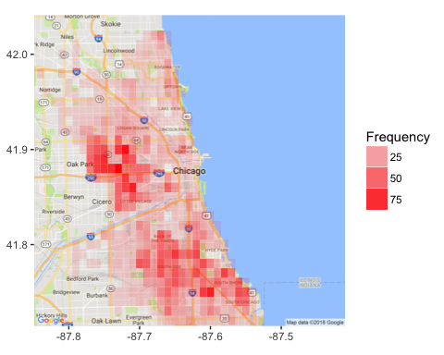

#The dataset that was used in order to create this graph was given by the city of Chicago. It has information regarding the homicides that occurred from 2001-to present, location, and time.

# Chicago’s Violence

The total number of homicides that have occurred in Chicago since 2001 is around 9,060 (City of Chicago, 2018). After placing the locations of these homicides on the heat chart you can see how most of the homicides occur in the South and West side of the city. The darker shades of red indicate higher homicides in that given location compared to the lighter shades. The x-axis in this heat graph is longitude and the y-axis is latitude which helped us to find the locations of the homicides in the city. The frequency measures the prevalence of homicides in the area. Applying these things together with the data given from the city helped create this map to show the occurrence of homicides in the city. The heat map gives us a visual representation where majority of it occurs. Interesting to note, other major cities like New York, Los Angeles, Houston, etc. have shown signs of progression in violence except for Chicago. Just recently in 2012, Chicago was given the title as “The Murder Capital of America” (Ward Room Staff, 2012). Since then Chicago has been one of the top five major cities with the highest homicide rates and hasn’t shown any signs of improvement.

chicago_homicide <- read.csv("Homicides (2).csv", stringsAsFactors = FALSE)  
chicago_homicide$Date <- strptime(chicago_homicide$Date, format = '%m/%d/%Y %I:%M:%S %p')  
chicago_homicide$Day <- weekdays(chicago_homicide$Date)  
chicago_homicide$Hour <- chicago_homicide$Date$hour  
dailyCrimes <- as.data.frame(table(chicago_homicide$Day, chicago_homicide$Hour))  
names(dailyCrimes) <- c('Day', 'Hour', 'Freq')  
dailyCrimes$Hour <- as.numeric(as.character(dailyCrimes$Hour))  
dailyCrimes$Day <- factor(dailyCrimes$Day, ordered = TRUE,   
 levels = c('Sunday', 'Monday', 'Tuesday', 'Wednesday', 'Thursday', 'Friday', 'Saturday'))  
ggplot(dailyCrimes, aes(x = Hour, y = Freq)) + geom_line(aes(group = Day, color = Day)) + xlab('Hour') + ylab('Number of homicides') + ggtitle('Timing of the Homicides')

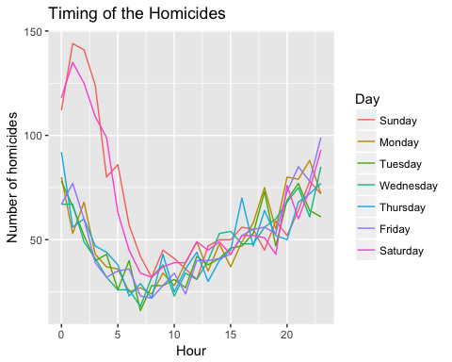

# Same dataset was used in this graph as the previous, but instead of specifying the location, this graph emphasizes on time and days when the homicides

occur.

# When Do These Homicides Occur?

In the line graph above you can see the trends when homicides occur by the hour and day. The colors indicate the different days of the week and in the x-axis, the time is measured in military timing. From the dataset given by the city, that most homicides occur during late nights on weekends and evenings on weekdays. The least timing for homicides to occur is early mornings or during school hours. After analyzing this information schools might have an impact on the homicide rates since school is in session around those times. Another reason why homicides were more likely to occur at night during weekends is that schools are off as well. Does this prove that violence and schools are related to one another in the city of Chicago? In order to answer this question, we have to analyze school closings.

# CPS School Closings

In addition to the homicide rates in Chicago, analyzing information on students that were being affected by CPS school closings was as important. It is estimated that about 54 Chicago Public Schools (CPS) have been terminated by the CPS board of education in recent years. No direct dataset was readily available to analyze these school closings. By creating my own CSV file with information regarding the locations of these schools made the process easier. This helped create a visualization of where most of these schools were closing. With help from the University of Chicago, we were provided with the listing of the schools that were closed and the schools that the students were transferred to from one of their research reports.

#Saving the data to Schools_closed  
Schools_closed <- read_csv("School Closings (1).csv")

## Parsed with column specification:  
## cols(  
## `School Name` = col_character(),  
## Year = col_integer(),  
## Neighborhood1 = col_character(),  
## Location1 = col_character(),  
## `Schools Welcoming` = col_character(),  
## Neighborhood2 = col_character(),  
## Location2 = col_character()  
## )

#Creating a Geom_bar with ggplot  
##This bar graph shows the number of school closing in a specific location in Chicago.  
##Figure(1)  
Schools_closed %>% ggplot(aes(x=Location1, color=Location1))+geom_bar(aes(fill=Location1))

## 

As you can see in the bar graph, it seems as though the majority of the school closings are located in the south and west side parts of Chicago. We were also curious as to where these students are transferring to, and the University of Chicago provided this information defining them as welcoming schools.

#This graph shows the number of welcoming schools in a specific location in Chicago  
##Figure(2)  
Schools_closed %>% ggplot(aes(x=Location2, color=Location2))+geom_bar(aes(fill=Location2))

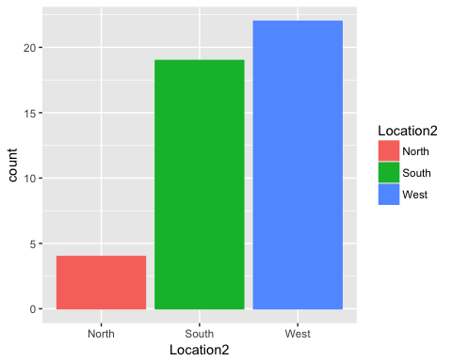

# Why are these schools closing?

# The common trend from this data seems that students are transferred to nearby schools. The students that attended schools that closed in the south side transferred to other schools in the south side, and etc. According to the Chicago's Board of Education, these schools closed due to poor academic performances, understaffed, and some were underutilized. The city believes more funds can be given to schools currently open by closing schools that seem unfit. This gives the city more money to fund other schools to improve their performances.

# Who is Affected?

misconducts_cps <- read_csv("Misconduct_Report_EOY2017_Citywide (1).csv")

## Warning: Duplicated column names deduplicated: '# of Students Expelled'  
## => '# of Students Expelled_1' [29], 'Expulsions per 100 Students' =>  
## 'Expulsions per 100 Students_1' [30], '# of Students Expelled' => '# of  
## Students Expelled_2' [31], 'Expulsions per 100 Students' => 'Expulsions per  
## 100 Students_2' [32]

## Parsed with column specification:  
## cols(  
## .default = col_integer(),  
## Category = col_character(),  
## Year = col_character(),  
## Period1 = col_character(),  
## `% of Misconducts Resulting in a Suspension` = col_double(),  
## `% of Misconducts Resulting in ISS` = col_double(),  
## `ISS per 100 Students` = col_double(),  
## `% of Unique Students Receiving ISS` = col_double(),  
## `Average Length of ISS` = col_character(),  
## `% of Misconducts Resulting in OSS` = col_double(),  
## `OSS per 100 Students` = col_double(),  
## `% of Unique Students Receiving OSS` = col_double(),  
## `Average Length of OSS` = col_character(),  
## `% of Misconducts Resulting in Police Notification` = col_double(),  
## `Police Notifications per 100 Students` = col_double(),  
## `% of Unique Students Receiving Police Notification` = col_double(),  
## `Expulsions per 100 Students` = col_double(),  
## `Expulsions per 100 Students_1` = col_double(),  
## `Expulsions per 100 Students_2` = col_double()  
## )

## See spec(...) for full column specifications.

misconducts_cps %>%ggplot(aes(x=Year, y=`# of Misconducts2`, color=Category))+geom_point()

## 

After analyzing the data with regards to the number of misconducts committed by CPS students through a geom-point graph, males have the highest number of misconducts, specifically African American male students. Marisa De La Torre has done a research report on this and published it at the University of Chicago CCSR in the year 2015, which showed who was affected mostly by these school closings. In her report, she found school closings impacted 88% of the African American youth that attended these schools (DeLaTorre, 2015). This strengthens the evidence creating a correlation to why most African American students reported the highest number of misconducts during the 2012-2013 school year. That same year was when the CPS board of education decided to close down 54 schools for the upcoming year. What we can deduct from this is that these students knew that there would be no repercussions for their actions because they would not be attending the school. As a result, they found it reasonable to break the school’s code of conduct. This might indicate why the number of misconducts was higher than any other school year. Also, it shows how school closings might have a negative effect towards these students. It might even have a reason for such a high homicide rate that year too. Even an article published by the Huffington post stated how in the year 2012 young students were impacted by the gun violence the most (HuffingtonPost,2012). Does this prove the correlation?

# Correlation?

# As we can see from the bar graph and the mapping of the violence, the majority of the violence and homicides are occurring in the areas where the schools have been shut down. As we know are the south and west sides of the city. After intensive research finding a correlation between homicide rates and school closings was difficult. In 2013, the city saw a drop in the homicide rates but that can be due to many factors. One of the biggest being, since Chicago faced a surreal number of homicide rates in 2012 and the following year would be impossible to top. An article published by Chicago Homicide watch noticed a decrease in homicides, but an increase in the overall number of shootings that happened across the city. It goes to show how statistics can be misleading and the numbers might not actually say what they mean.

# Conclusion

# A lot of things factor into violence and deaths across the city. School closings across the city can potentially be a factor in this violence. It is very difficult to find a direct correlation between the two, but after conducting this research it is clear that the two are somewhat related. School closings increase the likelihood of homicides and violence across the city. By closing Public Schools, we are putting the students at risk who have to commute to a different school and come across the violence during their travels. In addition, the students are more likely to also be situated with that violence rather than going to school. Another thing we can correlate is the year of the school closings with the year of the number of misconducts by the student. We can see that in the same year the schools were closed, which was the year 2013, is the same year where the students had the highest number of misconducts. This correlation tells us that students are more likely to engage activity that violates the code of conduct. In conclusion, not only does school closing contribute to the violence in Chicago, but also has an effect on student’s behaviors inside the classroom.

# Reference:

School closings: De la Torre, M., Gordon, M. F., Moore, P., & Cowhy, J. (2015, January). School Closings in Chicago: Understanding Families’ Choices and Constraints for New School Enrollment. Retrieved from <https://consortium.uchicago.edu/publications/school-closings-chicago-understanding-families-choices-and-constraints-new-school>

Homicide Watch: <http://chicago.homicidewatch.org/2014/12/28/chicagos-2014-murder-total-on-track-for-another-low-but-shootings-rise/>

Student Victoms: <https://www.huffingtonpost.com/2012/06/26/chicago-public-school-stu_n_1627258.html>

Homicide CSV: <https://data.cityofchicago.org/Public-Safety/Homicides/k9xv-yxzs/data>

CPS misconducts CSV: <https://cps.edu/SchoolData/Pages/SchoolData.aspx>